REFERENCE FORM

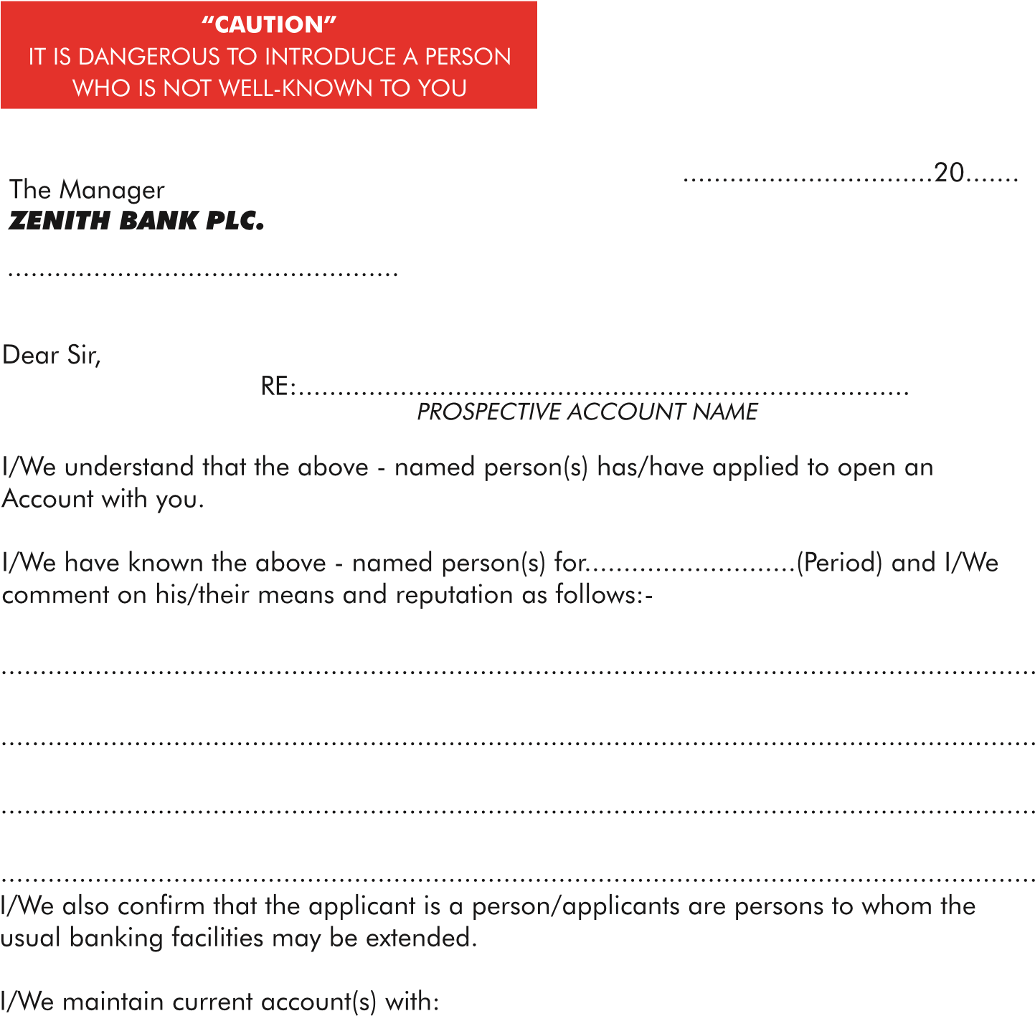

The Manager,

Preeminent MFB Ltd

|  |  |  |
| --- | --- | --- |
|  |  |  |
|  |  |  |
|  |  |  |

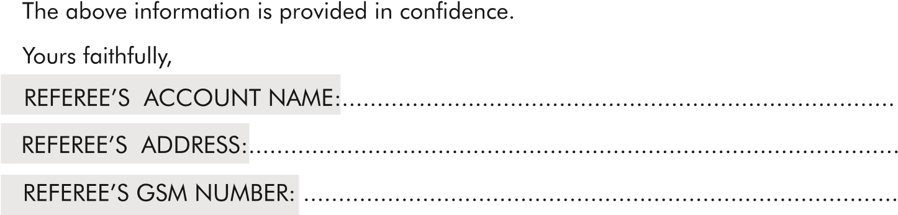

REFEREE’S SIGNATURE: …………………………………………………………………………………….